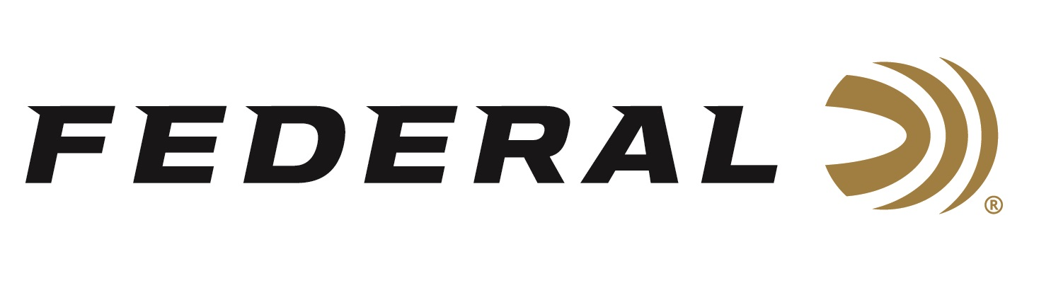

FOR IMMEDIATE RELEASE

**Federal Ammunition Introduces New Practice & Defend Packs**

**ANOKA, Minnesota – April 15, 2020 –** Pair the self-defense load proven by law enforcement with the industry’s most complete training ammunition for a combination like no other. New Federal Practice & Defend Packs include 50 HST Personal Defenseloads and 50 Syntech Training Match rounds. Shipments of this product have begun to arrive at dealers.

The two loads in these 100-count combo packs produce identical velocities, trajectories and point of impact for the most realistic training and utmost protection. Two loads each with a specific purpose in one package: Practice with the Syntech Training Match and carry the HST.

**Features & Benefits**

* Ballistically paired Syntech Training Match and HST loads
* Practice loads’ Total Synthetic Jacket prevents metal fouling, reduces barrel heat and friction, and minimizes splash-back against hard targets
* HST expands reliably through a variety of barriers and penetrates to ideal depths for self-defense situations
* Flawless function and reliability in semi-automatic pistols

**Part No. / Description / MSRP**

P9HST2TM100 / 9mm Luger 147-grain 100 Round HST/Syntech Training Match, 1000 fps / $60.99

P9HST1TM100 / 9mm Luger 124-grain 100 Round HST/Syntech Training Match, 1150 fps / $60.99

P40HST1TM100 / 40 S&W 180-grain 100 Round HST/Syntech Training Match, 1010 fps / $68.99

P45HST2TM100 / 45 Auto 230-grain 100 Round HST/Syntech Training Match, 890 fps / $73.99

Federal ammunition can be found at dealers nationwide or purchased online direct from Federal. For more information on all products from Federal or to shop online, visit [www.federalpremium.com](http://www.federalpremium.com).

**Press Release Contact: JJ Reich**

Senior Manager – Press Relations

E-mail: [VistaPressroom@VistaOutdoor.com](mailto:VistaPressroom@VistaOutdoor.com)

**About Federal Ammunition**

Federal, headquartered in Anoka, MN, is a brand of Vista Outdoor Inc., an outdoor sports and recreation company. From humble beginnings nestled among the lakes and woods of Minnesota, Federal Ammunition has evolved into one of the world's largest producers of sporting ammunition. Beginning in 1922, founding president, Charles L. Horn, paved the way for our success. Today, Federal carries on Horn's vision for quality products and service with the next generation of outdoorsmen and women. We maintain our position as experts in the science of ammunition production. Every day we manufacture products to enhance our customers' shooting experience while partnering with the conservation organizations that protect and support our outdoor heritage. We offer thousands of options in our Federal Premium and Federal® lines-it's what makes us the most complete ammunition company in the business and provides our customers with a choice no matter their pursuit.